**Project Initialization and Planning Phase**

| Date | 7 June, 2024 |
| --- | --- |
| Team ID | Xxxxxx |
| Project Name | Rice Type Classification Using CNN |
| Maximum Marks | 3 Marks |

**Problem Statement**

Rice classification is an important tool for maintaining the quality, efficiency and cost-effectiveness in the farming industry. People such as farmers, millers and distributors are in need of accurate rice classification techniques to classify rice grain into different categories to ensure the quality of the rice, increase efficiency in the sorting process and to meet market standards. Right now, classifying rice is often a manual and time-consuming task, not to mention it may be prone to errors.

The aim of this project is to develop a CNN (convolutional neural network) model that can quickly and accurately classify different types of rice. This model could be embedded in the rice processing workflow to enhance the efficiency and reduce the variability.

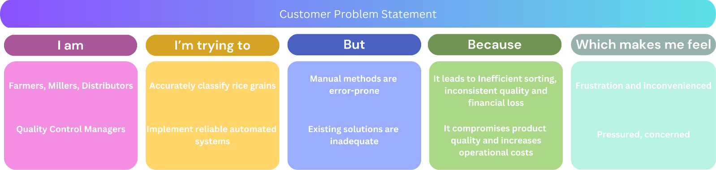

|  |  |  |  |  |
| --- | --- | --- | --- | --- |
| **Stakeholders** | **Goal** | **Challenge** | **Impact** | **Feeling** |
| Farmers, Millers, Distributors | Accurately classify rice grains | Manual methods are error-prone | Inefficient sorting, inconsistent quality, financial loss | Frustration, inefficiency |
| Quality Control Managers | Implement reliable automated systems | Existing solutions are inadequate | Compromised product quality, increased operational costs | Pressure, concern |

|  |  |  |  |  |  |
| --- | --- | --- | --- | --- | --- |
| **Problem Statement (PS)** | **I am (Customer)** | **I’m trying to** | **But** | **Because** | **Which makes**  **me feel** |
| PS-1 | Farmers, Millers, Distributors | Accurately classify rice grains | Manual methods are error-prone | It leads to inefficient sorting, inconsistent quality and financial loss | Frustration and inconvenienced |
| PS-2 | Quality Control Managers | Implement reliable automated systems | Existing solutions are inadequate | It compromises product  quality and increases operational costs | Pressured, concerned |